LAB # 04

Objective: To become familiar with report generation in OLTP systems

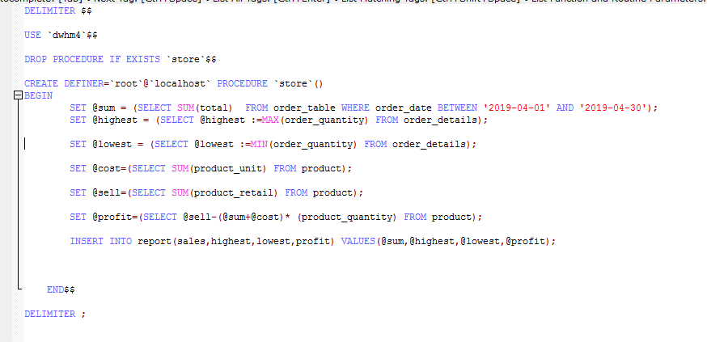

OUTPUT:

